Firstly, an encrypted file is created with the encrypted massage ‘this is accounting secret’. The encryption is an AES symmetric encryption done with openssl.



When the content of the file is viewed, it will display the encrypted message.



The user, group and owner are then given read and write permissions using the numerical method

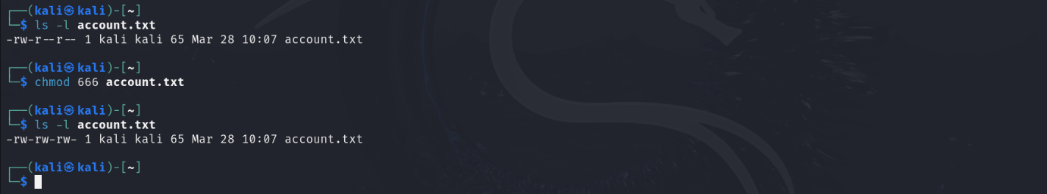

Afterwards, 5 users are created.(ade, bayo, charles, dami and emma).

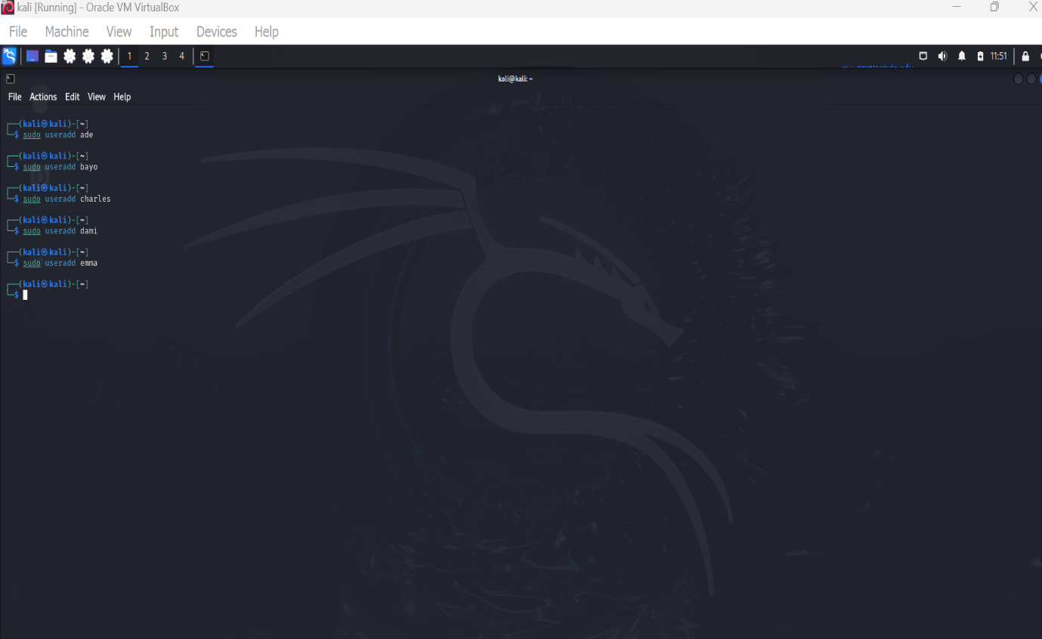

Then 2 groups (finance and IT) are created

User Ade and bayo are then added to IT



While user charles and dami are added to finance

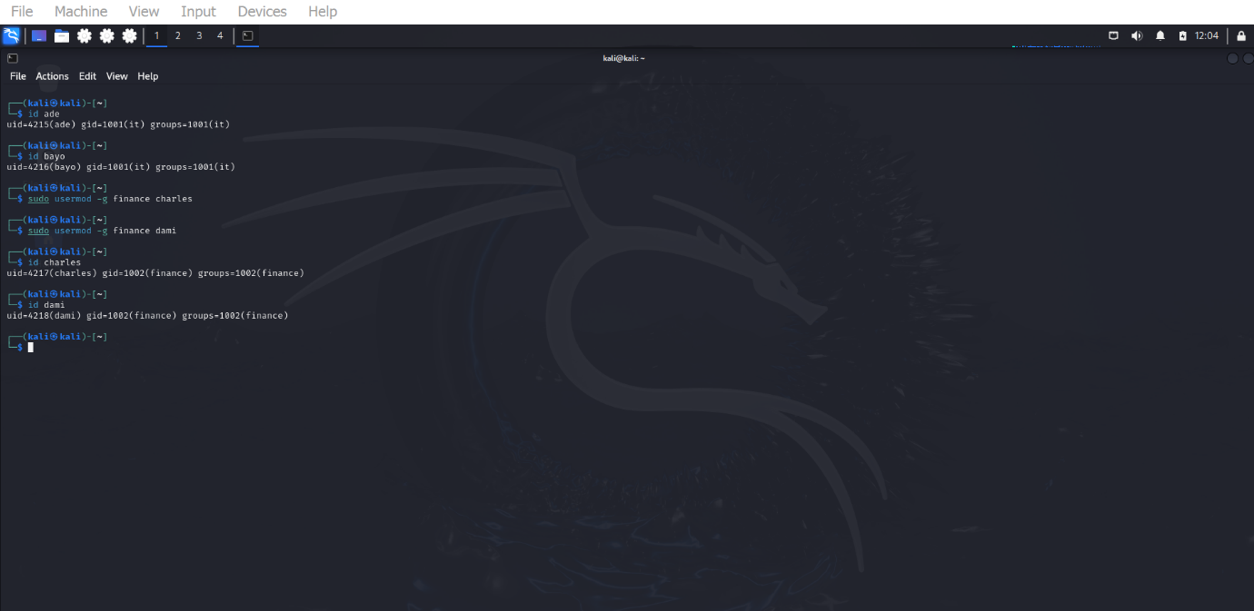

Using set file access control list, finance group is given read access.

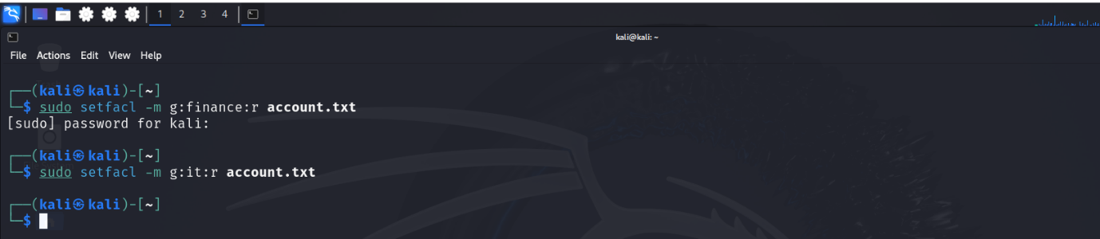

User emma is given read and write permission to the file account.txt



It group is also given read and write permission.

